This document will describe how I made a USB keyboard from a Lenovo ThinkPad T61 keyboard using a Teensy 3.2 microcontroller. All associated files are in the Teensy 3p2 folder under the Lenovo_thinkpad_t61 folder at my [Github repo.](https://github.com/thedalles77/USB_Laptop_Keyboard_Controller/tree/master/Example_Keyboards/Lenovo_ThinkPad_T61/) I have done similar conversions with other laptop keyboards but all of them had flexible printed circuit (FPC) cables that ended with exposed metal traces which fit into a generic connector. Lenovo T60, T61, T400, T500 laptops and their variants have a 44 pin connector plug soldered to the end of the FPC cable. The Lenovo motherboard has the mating socket connector. I designed a circuit board that contains a Teensy 3.2 microcontroller and a 44 pin socket connector. The picture below shows the circuit board connected to a ThinkPad T61 keyboard.

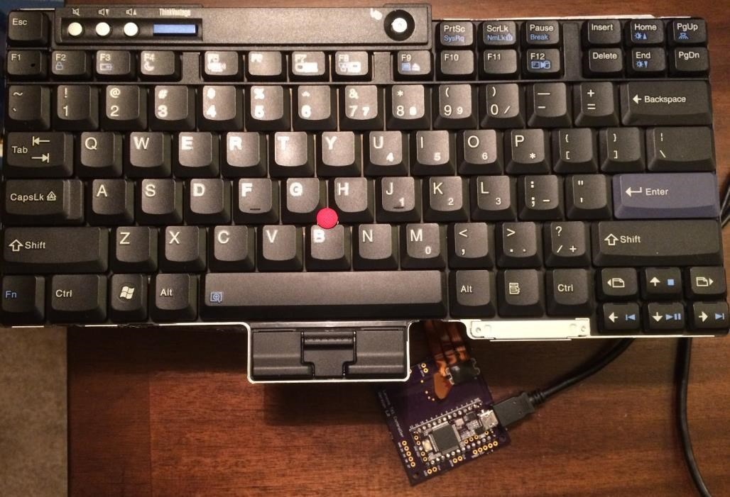

The bare and assembled board is shown below.

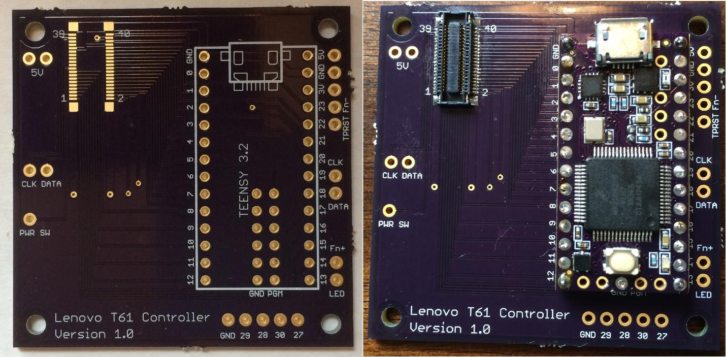

The Lenovo_Scanner.brd Eagle file for the circuit board was fabricated by OSH Park. The Eagle layout is shown below with descriptions for the pads.

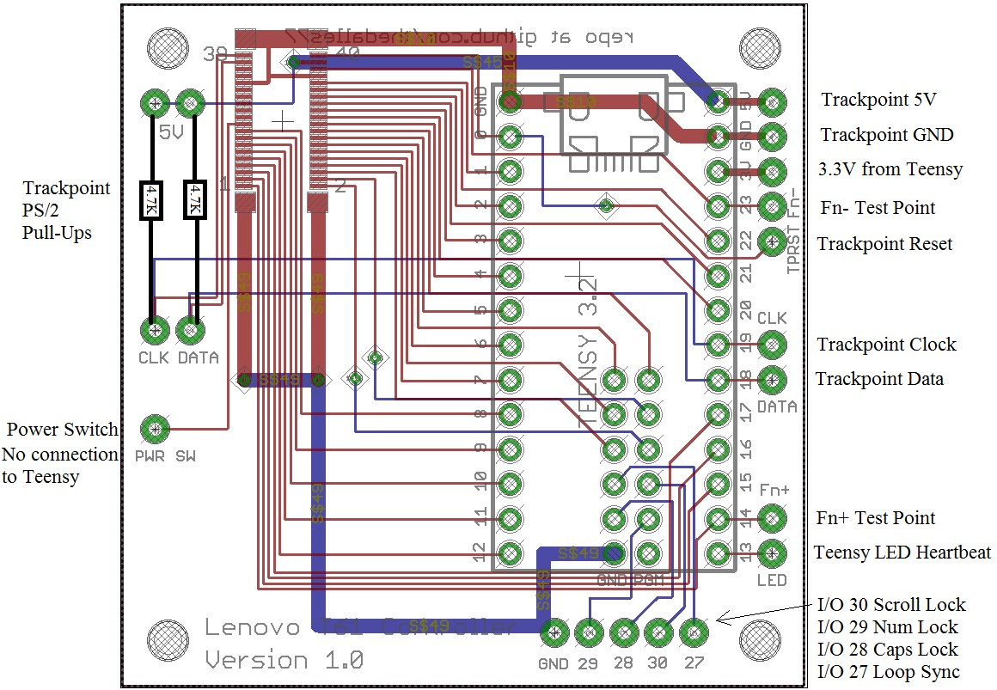

The surface mount pads on the backside of the Teensy 3.2 are wired to the board with flying leads as shown below. I like to use 4 header posts to support the Teensy and 30 gauge wire wrap wire for the rest of the board to board connections so I can easily cut the Teensy free if necessary. The alternative to using flying leads is right angle header pins like the ones in the [RB-Spa-1385](https://www.robotshop.com/en/teensy-header-kit.html) Teensy Header Kit from RobotShop. The 2x7 right-angle SMT will work if you cut it down to 2x6 and then pull out the 2 pins on one end and replace them with straight pins. The straight pins should go in the Teensy Ground and Program holes to help align the header.

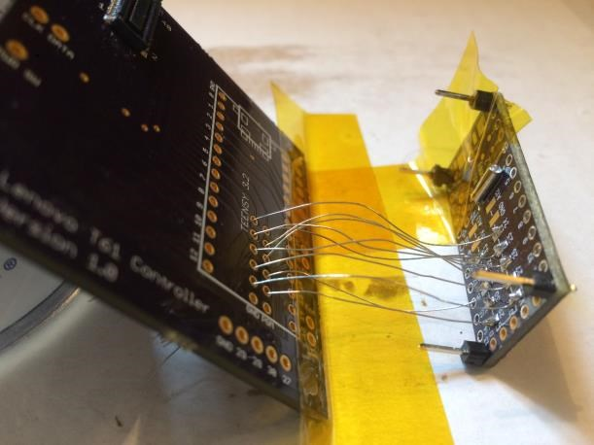

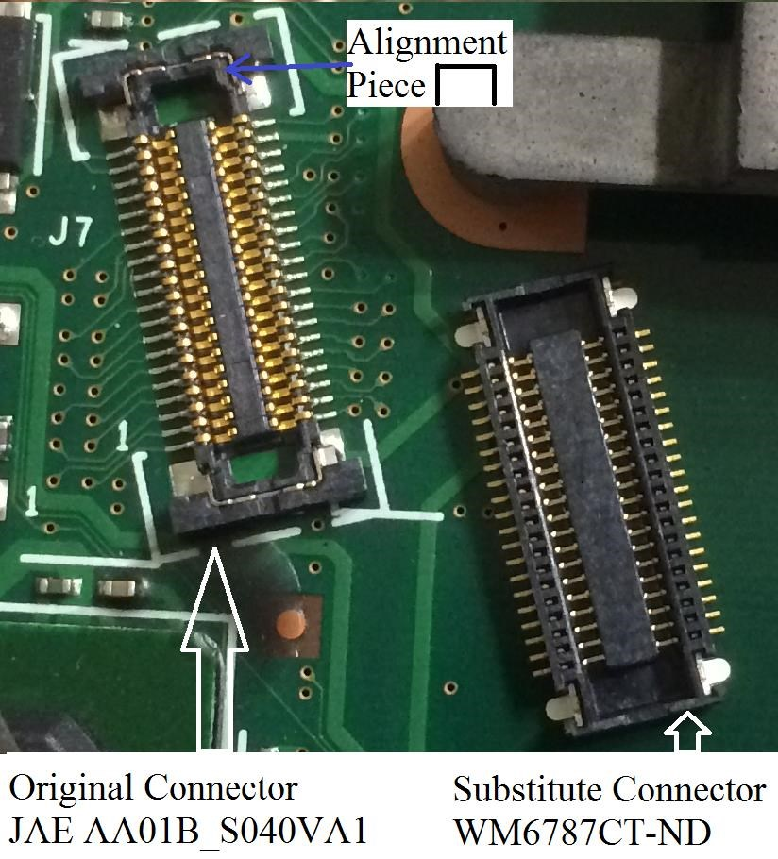

The WM6787CT-ND connector from Digikey will work with the Lenovo T61 keyboard but I did have some trouble with alignment. It took me several attempts to figure out how to center the plug before pushing it into the socket. With the Fn key pressed, I used an ohm meter on the Fn+ and Fn- pads on the board to see if the connecter was seated properly. Note that the “on” resistance of the Fn switch is about 225 ohms which may be too high to “beep” your meter. A possible cause of the alignment issue is shown in the picture above. The ends of the Digikey connector are missing the alignment piece found in the original JAE AA01B_S040VA1 connector. Once I got the plug correctly installed in the socket, it stayed connected so I don’t view this as a big problem. The alternative to using the Digikey connector is to search for the original JAE AA01B_S040VA1 connector or unsolder it from a broken motherboard. Forum posters have reported that the original connector is hard to find and only available in large lot sizes.

The keyboard connections to the Teensy 3.2 pins are shown below.

|  |  |  |
| --- | --- | --- |
| Lenovo ThinkPad T61 FPC Connector | Teensy 3.2 I/O number | T61 Schematic Signal Name |
| 1 | 14 | HOTKEY |
| 2 | 31 | DRV<4> |
| 3 | 15 | SENSE<5> |
| 4 | 32 | DRV<5> |
| 5 | 16 | SENSE<0> |
| 6 | 26 | DRV<8> |
| 7 | 17 | SENSE<3> |
| 8 | 7 | DRV<6> |
| 9 | 12 | SENSE<2> |
| 10 | 25 | DRV<3> |
| 11 | 11 | SENSE<4> |
| 12 | 6 | DRV<7> |
| 13 | 10 | SENSE<1> |
| 14 | 24 | DRV<2> |
| 15 | 9 | SENSE<6> |
| 16 | 5 | DRV<10> |
| 17 | 8 | SENSE<7> |
| 18 | 33 | DRV<1> |
| 19 | PWR SW Pad | PWR SW |
| 20 | 4 | DRV<9> |
| 21 | No connect | NC |
| 22 | 20 | DRV<0> |
| 23 | No connect | NC |
| 24 | 3 | DRV<11> |
| 25 | No connect | KBDID0 |
| 26 | 21 | DRV<14> |
| 27 | No connect | KBDID1 |
| 28 | 2 | DRV<12> |
| 29 | No connect | KBDID2 |
| 30 | 22 | DRV<15> |
| 31 | Teensy GND | KBDID RTN |
| 32 | 1 | DRV<13> |
| 33 | No connect | NC |
| 34 | Teensy GND | PWR SW RTN |
| 35 | No connect | NC |
| 36 | 23 | HOTKEY RTN |
| 37 | 18 | TP_DATA |
| 38 | Teensy 5V | TP_5V |
| 39 | 19 | TP_CLK |
| 40 | 0 | TP_RESET |
| 41 thru 44 | Teensy GND | GND |

The schematic for the connections on the circuit board is given below.

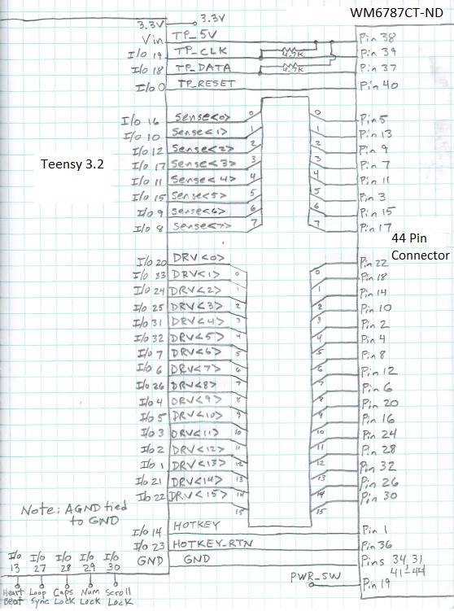

It was easy to find a Lenovo motherboard schematic online that provided me with the connector pins for the DRV and SENSE signals. The Matrix_Decoder_T61.ino code at my repo scans the DRV and SENSE pins and sends key press connection characters over USB for capture by an editor. The key press results in the file Lenovo_T61_io_list.txt at my repo were used to build the matrix table shown below. The Teensy inputs aka Sense<0> thru <7> are the columns across the top and the Teensy outputs aka Drive<0> thru <15> are the rows on the side.

Matrix for the Lenovo ThinkPad T61 – Keyboard Part Number 42T3177

|  |  |  |  |  |  |  |  |  |
| --- | --- | --- | --- | --- | --- | --- | --- | --- |
| **Teensy 3.2 I/O Number** | **Sense<0> I/O 16** | **Sense<1> I/O 10** | **Sense<2> I/O 12** | **Sense<3> I/O 17** | **Sense<4> I/O 11** | **Sense<5> I/O 15** | **Sense<6 > I/O 9** | **Sense<7> I/O 8** |
| **Drive<0> I/O 20** | Back-Tick | 1 | Q | Tab | A | Esc | Z |  |
| **Drive<1> I/O 33** | F1 | 2 | W | CapsLock | S |  | X |  |
| **Drive<2> I/O 24** | F2 | 3 | E | F3 | D | F4 | C |  |
| **Drive<3> I/O 25** | 5 | 4 | R | T | F | G | V | B |
| **Drive<4> I/O 31** | 6 | 7 | U | Y | J | H | M | N |
| **Drive<5> I/O 32** | Equal | 8 | I | Right-  Brace | K | F6 | Comma |  |
| **Drive<6> I/O 7** | F8 | 9 | O | F7 | L |  | Period |  |
| **Drive<7> I/O 6** | Minus | 0 | P | Left-  Brace | Semi-colon | Quote |  | Forward-  Slash |
| **Drive<8> I/O 26** | F9 | F10 |  | Back-  Space | Back-Slash | F5 | Enter | Space |
| **Drive<9> I/O 4** | Insert | F12 |  |  | Possible Fn location |  |  | Arrow-  Right |
| **Drive<10> I/O 5** | Delete | F11 | VolumeUp | VolumeDown | Mute | Think-  Vantage |  | ArrowDown |
| **Drive<11> I/O 3** | Page-Up | Page-  Down | **GUI** |  | Menu |  | PageLeft | Page-  Right |
| **Drive<12> I/O 2** | Home | End |  |  |  | Arrow-Up | Pause | Arrow-  Left |
| **Drive<13> I/O 1** |  | Print-  Screen | ScrollLock |  |  | **Alt-L** |  | **Alt-R** |
| **Drive<14> I/O 21** |  |  |  | **Shift-L** |  |  | **Shift-R** |  |
| **Drive<15> I/O 22** | **Cntrl-L** |  |  |  |  |  | **Cntrl_R** |  |

The Fn “Hotkey” has its own dedicated pins and is not part of the matrix. Fn is wired to connector pins 1 and 36 (Teensy I/O’s 14 and 23). To read the Fn key, I/O 23 is driven low and I/O 14 is read as an input with a pullup. Instead of just grounding the Fn return signal at the connector, I brought both sides of the Fn switch to the Teensy and to pads on the board. This allowed me to temporarily jumper the Fn key into the matrix to confirm I could scan it along with all the other keys. The location I tested in the matrix for the Fn key is the empty cell between I/O 4 and I/O 11 as shown above. Placing the Fn switch in the matrix could be useful if you are trying to save Teensy I/O pins (see Teensy LC controller board). For the Teensy 3.2 implementation, I have kept the Fn key out of the matrix.

With the key matrix information shown above, you can use Matt3o’s [step by step instructions](https://deskthority.net/workshop-f7/how-to-build-your-very-own-keyboard-firmware-t7177.html) to load the TMK software into the Teensy. I have written a keyboard and trackpoint routine as a simple alternative called [Lenovo_T61_KBandTP.ino.](https://github.com/thedalles77/USB_Laptop_Keyboard_Controller/tree/master/Example_Keyboards/Lenovo_ThinkPad_T61/) It uses the Teensyduino "Micro-Manager Method" to send keys over USB. All of the normal and modifier keys are supported but only the volume control multimedia keys are part of this routine. A description of the Teensyduino keyboard functions is at [www.pjrc.com/teensy/td_keyboard.html.](http://www.pjrc.com/teensy/td_keyboard.html)

The PS/2 code for the Trackpoint was originally from [Playground Arduino](https://playground.arduino.cc/uploads/ComponentLib/mouse.txt) but I changed the interface from RS232 serial to USB using the PJRC Mouse functions. A watchdog timer was also added to the "while loops" so the code can't hang if the Teensy misses a clock edge. This can happen when the Teensy is interrupted by the USB port to receive the keyboard_leds data.

Trackpoint testing with the Teensy shows that a stronger pullup for the PS/2 clock and data is needed than the weak pullups on the Teensy inputs. My board has thru-hole pads for clock and data pull up resistors to the left of the Digikey connector. 4.7K pullups per the Lenovo schematic worked and 10K’s also worked. The 10K pullups were part of the [BSS138](https://www.adafruit.com/product/757?gclid=Cj0KCQjwjbveBRDVARIsAKxH7vkxAQUQ9POOVKs4A6NRdP56qfXnAsTX3aUOMZpdvH7tfT3Jipe-0wAaAkV5EALw_wcB) level shifter board from Adafruit. The Teensy 3.2 doesn’t need level translators since it has 5 volt tolerant I/O but I wanted to confirm the translator works for possible use by a Teensy LC.

I designed a second T61 controller board that uses a Teensy LC based on the information learned from the 3p2 board. See the project description and all associated files in the Teensy LC folder at my GitHub repo. To use a Teensy LC instead of a 3.2, the following changes were made to the design:

1. Added two BSS138 FETs with four 10K pullups to translate the trackpoint Clock and Data signals to 5 volts.
2. Added a TLV810MDBZR 5 volt reset generator for power-on-reset to the trackpoint.
3. Moved the Fn key into the matrix as follows: Tie keyboard connector pin 1 to pin 11 and pin 36 to pin 20.
4. The keyboard uses 24 Teensy I/O’s and the trackpoint uses 2 I/O’s, leaving 1 I/O for a CAPS LOCK led. The LED on the Teensy LC uses 3ma out of the 5ma available so the external LED will need to use 2ma or less. The alternative is to remove the LED on the Teensy.